IOWA PAINT HORSE CLUB MEMORIAL DAY ENTRY FORM

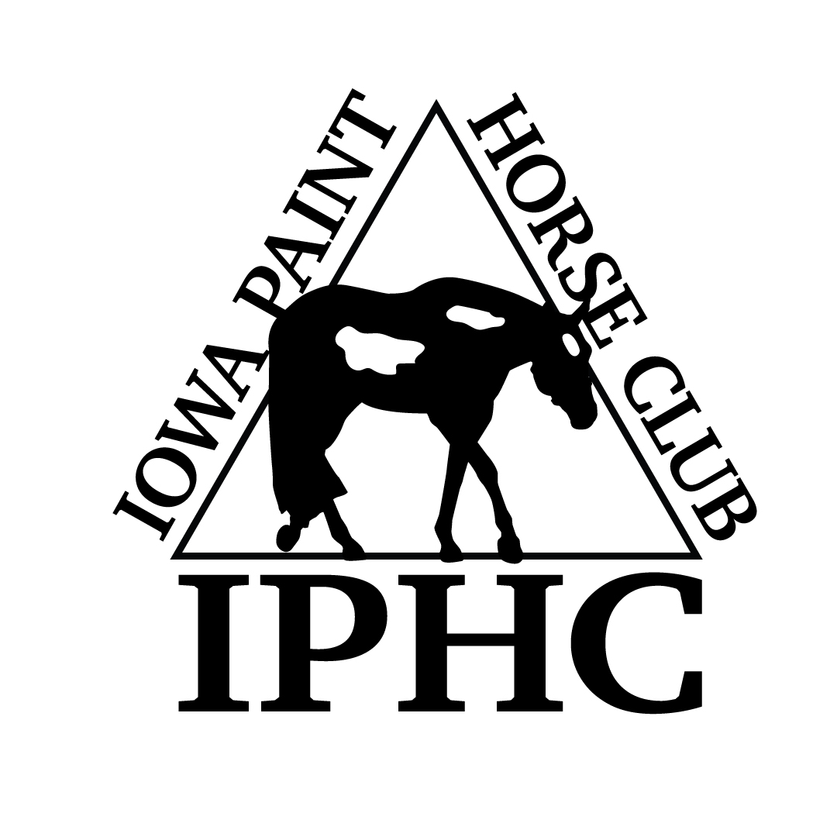
HORSE REGISTRATION PAPERS MUST BE IN HAND FOR VERIFICATION OF OWNERSHIP. CURRENT MEMBERSHIP CARDS MUST BE PRESENTED AT THE SHOW.
April 26-27, 2014 2014

Back #

Name of person who will be paying this horses’s fees:

HORSE INFORMATION (As it appears on the Registration Papers)

Registered Name: Reg. #: Foal Year:
- Mare
- Gelding
- Stallion

Trainer/Stalled With

OWNER INFORMATION (As it appears on the Registration Papers)

{jpj

Owner APHA # Exp.Date Phone #

Address City,State, Zip

Email

EXHIBITOR INFORMATION (Date of Birth “DOB” required for Youth only)
DP)

EXHIBITOR # 1

EXHIBITOR # 2
Name  APHA # Exp.Date DOB  Address  City,State,Zip  Phone Email  Relationship to Owner  Rider Status: ___ Open ____Amateur ____Novice _____Youth | Name  APHA # Exp.Date DOB  Address  City,State,Zip  Phone Email  Relationship to Owner  Rider Status: ___ Open ____Amateur ____Novice _____Youth
# 1  EXHIBITOR # 3  Name  APHA # Exp.Date DOB  Address  City,State,Zip  Phone Email  Relationship to Owner  Rider Status: ___ Open ____Amateur ____Novice _____Youth | SATURDAY Fees for 4 judges:  All fees represent a per day/per horse fee, unlimited exhibitors. No office fee, no APHA fee. Stall fee is separate.  - 4 Classes or more == $160/per horse  - 2-3 Classes == $110/per horse  - 1 Class == $60/per horse  SUNDAY/MONDAY Fees for 4 judges:  - 4 Classes or more == $160/per horse  - 2-3 Classes == $110/per horse  - 1 Class == $60/per horse  - STALLS: $75 in attached barn; $65 in detached barns. ALL HORSES MUST HAVE A STALL – NO JUMP OUTS ALLOWED  - REQUIRED to purchase 2 bags of shavings for each horse stall. SHAVINGS at $8.50/bag  - Lead Line class (90) is FREE  - Longeline: APHA rules  - NOTES: 1) If the horse shows in a riding class, halter classes will not count toward your number of classes. 2) Showmanship & Color Classes are NOT halter classes. 3) Longeline: APHA rules. 4) Show Management reserves the right to combine classes. 5) All bedding must be purchased from the facility. 6) Per APHA rules, no 2-year old horse may be exhibited in a performance class prior to May 15. Exceptions: Showmanship and 2 Year Old Longe Line.  Youth/Novice Youth Classes  Amateur/Novice Amateur Classes  Open Classes
Enter Exhibitor # for each applicable class/day instead of an “X”

 |  | SAT |  | SUN | MON |  |  |  | S  A  T | SUN | MON |  |  | SAT | S  UN | MON
22 | Yth W-T Showmanship 5-10 |  |  |  |  |  | 1 | Amateur Pleasure Driving |  |  |  | 2 | Pleasure Driving
23 | Nov Youth Showmanship 18/U |  |  |  |  |  | 3 | Amateur Stallions – All Ages |  |  |  | 9 | Junior SPB Stallions (2 & Under)
24 | Youth Showmanship 13/U |  |  |  |  |  | 6 | Amateur SPB Stallions – All Ages |  |  |  | 10 | Senior SPB Stallions (3 & Over)
25 | Youth Showmanship 18/U |  |  |  |  |  | 21 | Amat Walk-Trot Showmanship |  |  |  | 13 | Performance Halter Stallions
29 | Youth Mares |  |  |  |  |  | 26 | Nov Amateur Showmanship |  |  |  | 14 | Weanling Stallions
49 | Youth Geldings |  |  |  |  |  | 27 | Amateur Showmanship |  |  |  | 15 | Yearling Stallions
74 | Yth W-T Hunter U/Saddle 5-10 |  |  |  |  |  | 28 | SPB Amateur Showmanship |  |  |  | 16 | Two Year Old Stallions
76 | Yth W-T Hunt Seat Eq 5-10 |  |  |  |  |  | 30 | Amateur Mares |  |  |  | 17 | Three Year Old Stallions
77 | Nov Yth Hunter U/Saddle 18/U |  |  |  |  |  | 33 | Amateur SPB Mares All Ages |  |  |  | 18 | Four Year & Older Stallions
78 | Yth Hunter U/Saddle 13/U |  |  |  |  |  | 50 | Amateur Geldings |  |  |  | 36 | SPB Mares (2 Years & Under)
79 | Yth Hunter U/Saddle 18/U |  |  |  |  |  | 53 | Amateur SPB Geldings – All Ages |  |  |  | 37 | SPB Mares (3 Years & Over)
85 | Nov Yth Hunt Seat Eq 18/U |  |  |  |  |  | 69 | Amateur Yearling Longe Line |  |  |  | 40 | Performance Halter Mares
86 | Youth Hunt Seat Eq 13/U |  |  |  |  |  | 73 | Amat W-T Hunter Under Saddle |  |  |  | 41 | Weanling Mares
87 | Yth Hunt Seat Eq 18/Under |  |  |  |  |  | 75 | Amateur Walk-Trot Equitation |  |  |  | 42 | Yearling Mares
90 | Lead Line 8 & Under |  |  |  |  |  | 81 | Nov Am Hunter Under Saddle |  |  |  | 43 | Two Year Old Mares
93 | Yth W-T Western Pleasure 5-10 |  |  |  |  |  | 82 | Amateur Hunter Under Saddle |  |  |  | 44 | Three Year Old Mares
94 | Yth W-T Horsemanship 5-10 |  |  |  |  |  | 83 | SPB Amateur Hunter U/Saddle |  |  |  | 45 | Four Year & Older Mares
98 | Nov Yth West Pleasure 18/U |  |  |  |  |  | 88 | Nov Amateur Hunt Seat Eq |  |  |  | 46 | Broodmares
99 | Yth Western Pleasure 13/U |  |  |  |  |  | 89 | Amateur Hunt Seat Equitation |  |  |  | 56 | SPB Geldings (2 Years & Under)
100 | Yth Western Pleasure 18/U |  |  |  |  |  | 92 | Amateur W-T Western Pleas. |  |  |  | 57 | SPB Geldings (3 Years & Over)
105 | Nov Yth Horsemanship 18/U |  |  |  |  |  | 95 | Amateur W-T Horsemanship |  |  |  | 60 | Performance Halter Geldings
106 | Youth Horsemanship 13/U |  |  |  |  |  | 102 | Nov Amat Western Pleasure |  |  |  | 61 | Yearling Geldings
107 | Youth Horsemanship 18/U |  |  |  |  |  | 103 | Amateur Western Pleasure |  |  |  | 62 | Two Year Old Geldings
110 | Youth Western Riding 18/U |  |  |  |  |  | 104 | SPB Amat Western Pleasure |  |  |  | 63 | Three Year Old Geldings
117 | Youth Walk-Trot Trail 5-10 |  |  |  |  |  | 108 | Nov Amateur Horsemanship |  |  |  | 64 | Four Year & Older Geldings
118 | Novice Youth Trail 18/U |  |  |  |  |  | 109 | Amateur Horsemanship |  |  |  | 67 | Overo Color
119 | Youth Trail 18/U |  |  |  |  |  | 112 | Nov Amateur Western Riding |  |  |  | 68 | Tobiano Color
124 | Youth Ranch Riding 18/U |  |  |  |  |  | 113 | Amateur Western Riding |  |  |  | 70 | SPB Yearling Longe Line
127 | Youth Ranch Pleasure |  |  |  |  |  | 116 | Amateur Walk-Trot Trail |  |  |  | 71 | Yearling Longe Line
130 | Youth Ranch Reining |  |  |  |  |  | 121 | Novice Amateur Trail |  |  |  | 72 | SPB Hunter Under Saddle
133 | Youth Reining 18/U |  |  |  |  |  | 122 | Amateur Trail |  |  |  | 80 | Green Hunter Under Saddle
Horses are entered at your own risk and are subject to each specific association rules under which these classes will be conducted. In case of death, accident, injury or theft to the exhibitor, their family, horses or property, no claims will be honored either against this show or managing facility. |  |  |  |  |  |  | 125 | Amateur Ranch Riding |  |  |  | 84 | Hunter Under Saddle
 |  |  |  |  |  |  | 131 | Amateur Ranch Reining |  |  |  | 91 | Green Western Pleasure
 |  |  |  |  |  |  | 134 | Amateur Reining |  |  |  | 96 | SPB Western Pleasure
 |  |  |  |  |  |  | *Horses may enter either regular halter or performance halter, not both. This does not prohibit a horse from being shown in a Youth and/or Amateur halter class in addition to the  open age-group/performance halter class. Horses entered in performance halter MUST enter and participate in a performance class, other than showmanship, that same day. |  |  |  |  | 97 | Junior Western Pleasure
 |  |  |  |  |  |  |  |  |  |  |  | 101 | Senior Western Pleasure
 |  |  |  |  |  |  |  |  |  |  |  | 111 | Green Western Riding
 |  |  |  |  |  |  |  |  |  |  |  | 114 | Western Riding
 |  |  |  |  |  |  |  |  |  |  |  | 115 | Yearling In-Hand Trail
# STALLS ____________# TACK STALLS__________  SHAVINGS __________ NUMBER FEE __________  CAMPING ____________NIGHTS  IPHC Membership ____________ |  |  |  |  |  |  |  |  |  |  |  | 120 | Green Trail
 |  |  |  |  |  |  |  |  |  |  |  | 123 | Trail
 |  |  |  |  |  |  |  |  |  |  |  | 126 | Ranch Riding
 |  |  |  |  |  |  |  |  |  |  |  | 129 | Ranch Pleasure
 |  |  |  |  |  |  |  |  |  |  |  | 132 | Ranch Reining
 |  |  |  |  |  |  |  |  |  |  |  | 135 | Reining
 |  |  |  |  |  |  | Please complete and email to westphal@partnercom.net or mail to Cindy Westphal, 13696 N. 107th Ave E – Gilman, IA 50106

