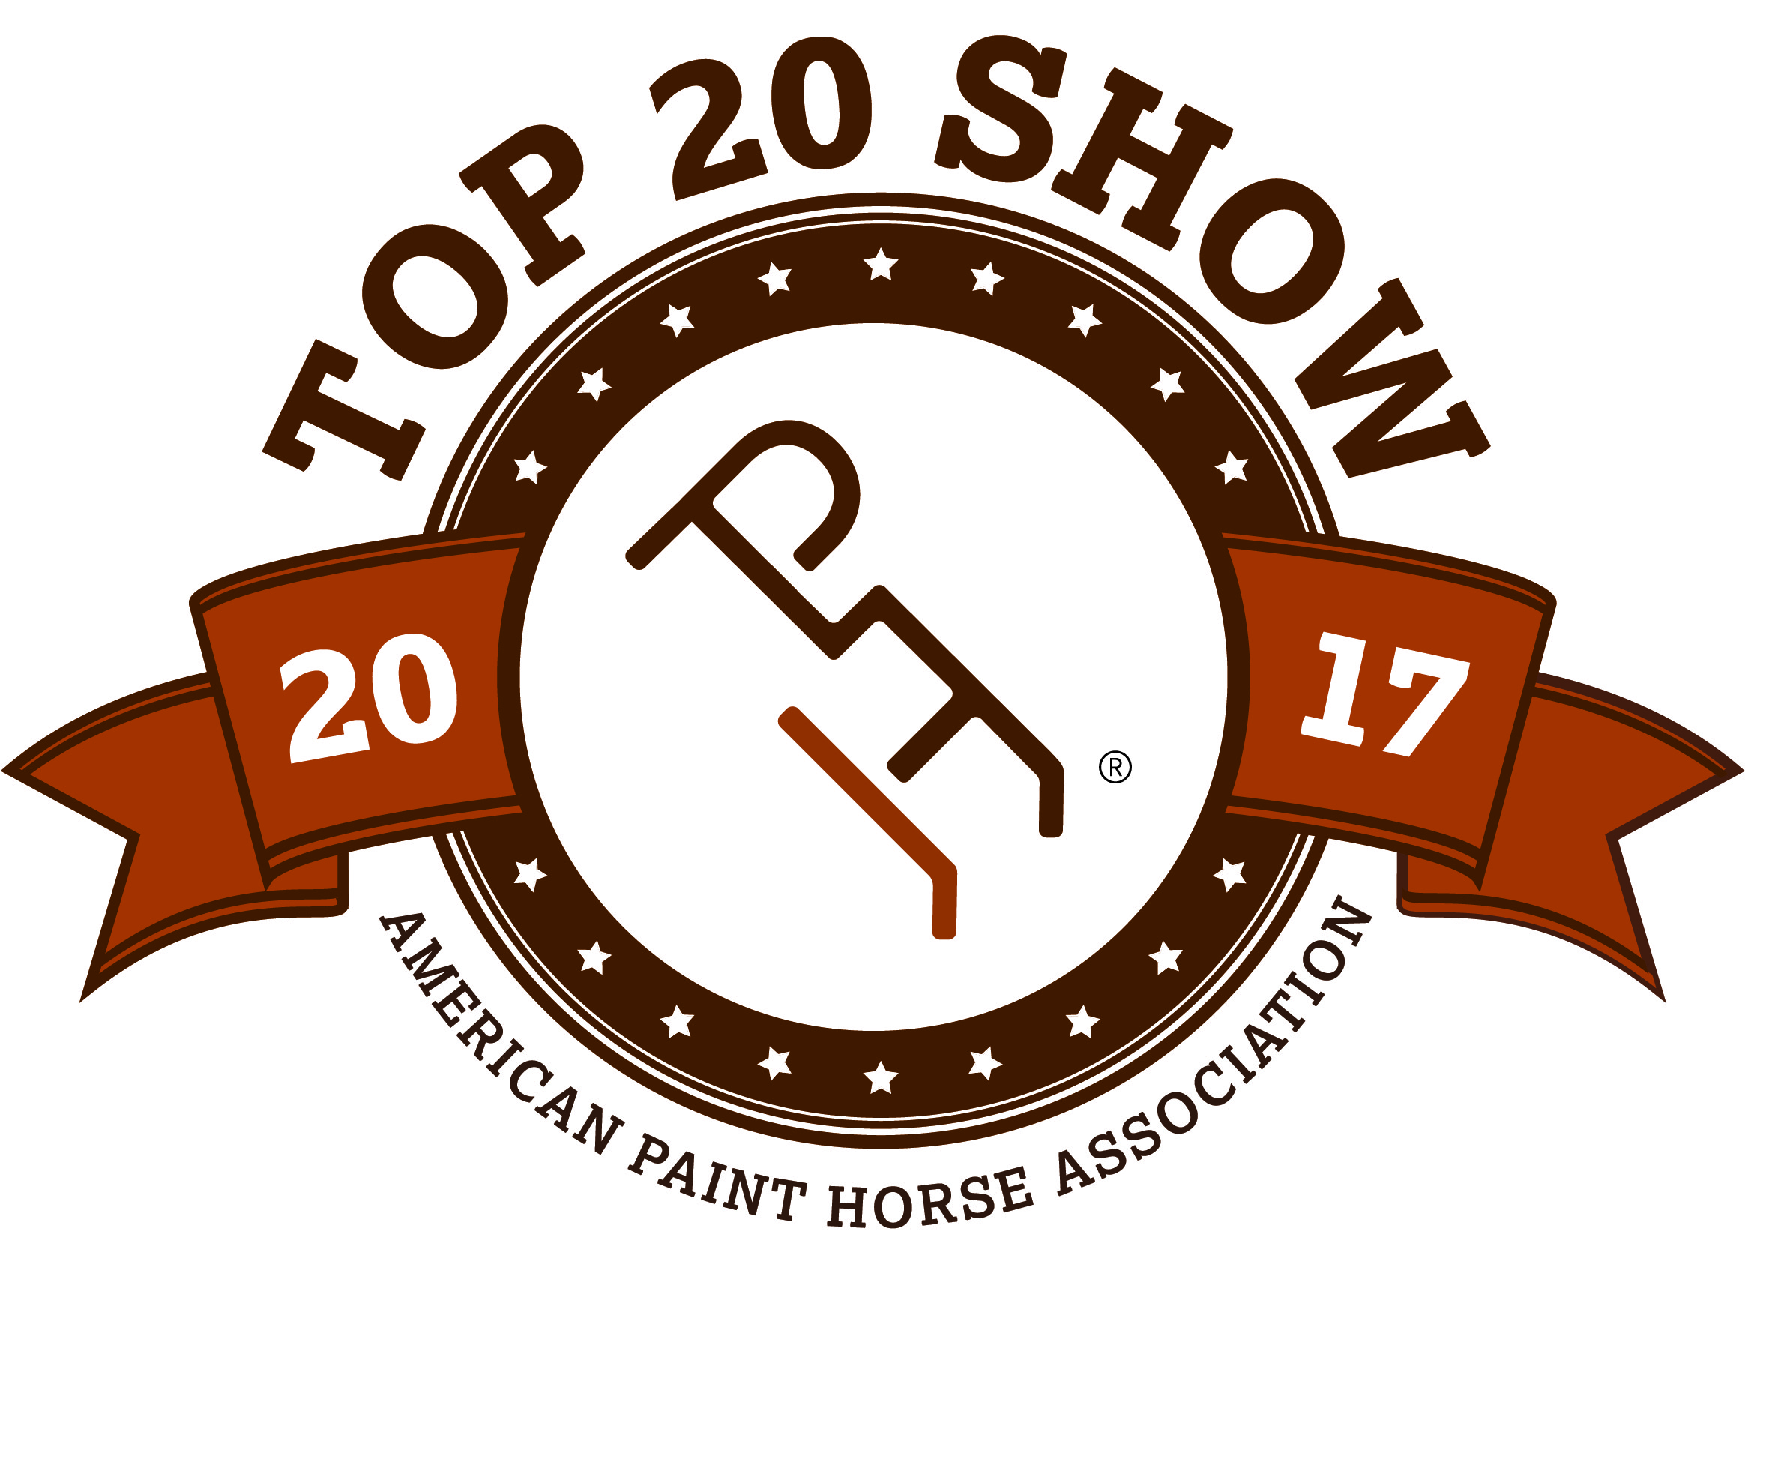
2018 APHA ZONE 5
ZONE-O-RAMA SHOW
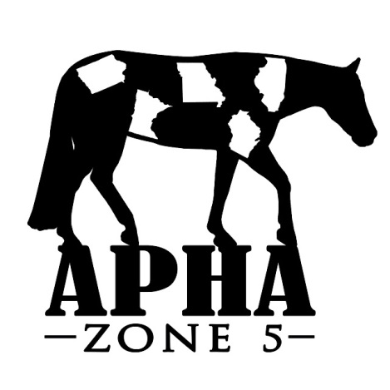

HORSE REGISTRATION PAPERS MUST BE IN HAND FOR VERIFICATION OF OWNERSHIP. CURRENT MEMBERSHIP CARDS, BOTH OWNER & EXHIBITOR MUST BE PRESENTED AT THE SHOW.

BACK #

Name of person who will be paying this horses’s fees:

HORSE INFORMATION (As it appears on the Registration Papers)
SPB?
- Yes
- No
- Mare
- Gelding
- Stallion

Registered Name Reg #

Trainer/Stalled With Foal Year
OWNER INFORMATION (As it appears on the Registration Papers)
{jpj

Owner APHA # Exp. Date

Address City, State, Zip

Email Phone
EXHIBITOR INFORMATION
DP)
Status |  |  | APHA/AJPHA # | EXP. DATE
Open
Amateur
Nov. Am
Youth
Nov. Youth

EXHIBITOR 1

Address

City, State, Zip

Phone Email

Relationship to Owner DOB

Status |  |  | APHA/AJPHA # | EXP. DATE
Open
Amateur
Nov. Am
Youth
Nov. Youth
EXHIBITOR 2

Address

City, State, Zip

Phone Email

Relationship to Owner DOB

Status |  |  | APHA/AJPHA # | EXP. DATE
Open
Amateur
Nov. Am
Youth
Nov. Youth

EXHIBITOR 3

Address

City, State, Zip

Phone Email

Relationship to Owner DOB

 |  |  |  | EXH # |  |  |  |  |  | EXH # |  |  |  |  |  | EXH #
YOUTH -- NOVICE YOUTH |  |  |  | SAT | SUN |  | AMATEUR – NOVICE AM – SPB AM |  |  | SAT | SUN |  | OPEN |  |  |  | SAT | SUN
3 |  | Youth Mares |  |  |  |  | 1 |  | Amateur Pleasure Driving |  |  |  | 2 |  | Pleasure Driving
23 |  | Nov Yth Showmanship 18/U |  |  |  |  | 4 |  | Amateur Mares |  |  |  | 10 |  | Performance Halter Mares
25 |  | Youth Showmanship 13/U |  |  |  |  | 7 |  | SPB Amateur Mares |  |  |  | 11 |  | Aged Mares
26 |  | Youth Showmanship 18/U |  |  |  |  | 24 |  | Nov Am Showmanship |  |  |  | 12 |  | 3 Year Old Mares
29 |  | Youth Geldings |  |  |  |  | 27 |  | Amateur Showmanship |  |  |  | 13 |  | 2 Year Old Mares
72 |  | Nov Yth Hunter Under Saddle |  |  |  |  | 28 |  | SPB Amateur Showmanship |  |  |  | 14 |  | Yearling Mares
74 |  | Youth Hunter U/Saddle 13/U |  |  |  |  | 30 |  | Amateur Geldings |  |  |  | 17 |  | SPB Junior Mares 2/Under
75 |  | Youth Hunter U/Saddle 18/U |  |  |  |  | 33 |  | SPB Amateur Geldings |  |  |  | 18 |  | SPB Senior Mares 3/Over
80 |  | Nov Yth Hunt Seat Equitation |  |  |  |  | 49 |  | Amateur Stallions |  |  |  | 36 |  | Performance Halter Geldings
82 |  | Yth Hunt Seat Equitation 13/U |  |  |  |  | 52 |  | SPB Amateur Stallions |  |  |  | 37 |  | Aged Geldings
83 |  | Yth Hunt Seat Equitation 18/U |  |  |  |  | 73 |  | Nov Am Hunter Under Saddle |  |  |  | 38 |  | 3 Year Old Geldings
86 |  | Youth Hunter Hack 18/U |  |  |  |  | 76 |  | Amateur Hunter Under Saddle |  |  |  | 39 |  | 2 Year Old Geldings
89 |  | Youth Western Riding 18/U |  |  |  |  | 77 |  | SPB Amat Hunter U/Saddle |  |  |  | 40 |  | Yearling Geldings
93 |  | Youth Reining 18/U |  |  |  |  | 81 |  | Nov Am Hunt Seat Equitation |  |  |  | 43 |  | SPB Junior Geldings 2/Under
96 |  | Youth Ranch Riding 18/U |  |  |  |  | 84 |  | Amat Hunt Seat Equitation |  |  |  | 44 |  | SPB Senior Geldings 3/Over
99 |  | Youth Barrel Racing18/U |  |  |  |  | 85 |  | SPB Amateur Hunt Seat Eq |  |  |  | 47 |  | Overo Color
102 |  | Youth Pole Bending 18/U |  |  |  |  | 87 |  | Amateur Hunter Hack |  |  |  | 48 |  | Tobiano Color
105 |  | Youth Stake Race 18/U |  |  |  |  | 91 |  | Amateur Western Riding |  |  |  | 55 |  | Performance Halter Stallions
111 | Nov Youth Trail 18/U |  |  |  |  |  | 94 |  | Amateur Reining |  |  |  | 56 |  | Aged Stallions
113 |  | Youth Trail 18/U |  |  |  |  | 97 |  | Amateur Ranch Riding |  |  |  | 57 |  | 3 Year Old Stallions
118 |  | Youth Lead Line |  |  |  |  | 100 |  | Amateur Barrel Racing |  |  |  | 58 |  | 2 Year Old Stallions
126 |  | Nov Youth Western Pleasure |  |  |  |  | 103 |  | Amateur Pole Bending |  |  |  | 59 |  | Yearling Stallions
128 | Youth Western Pleasure 13/U |  |  |  |  |  | 106 |  | Amateur Stake Race |  |  |  | 62 |  | SPB Junior Stallions 2/Under
129 |  | Youth Western Pleasure 18/U |  |  |  |  | 112 |  | Novice Amateur Trail |  |  |  | 63 |  | SPB Senior Stallions 3/Over
134 |  | Nov Youth Horsemanship |  |  |  |  | 114 |  | Amateur Trail |  |  |  | 66 |  | Green Hunter Under Saddle
136 |  | Youth Horsemanship 13/U |  |  |  |  | 115 |  | SPB Amateur Trail |  |  |  | 71 |  | Junior Hunter Under Saddle
137 |  | Youth Horsemanship 18/U |  |  |  |  | 127 |  | Nov Am Western Pleasure |  |  |  | 78 |  | Senior Hunter Under Saddle
 |  |  |  |  |  |  | 130 |  | Amateur Western Pleasure |  |  |  | 79 |  | SPB Hunter Under Saddle
 |  |  |  |  |  |  | 131 |  | SPB Amat Western Pleasure |  |  |  | 88 |  | Hunter Hack
 |  |  |  |  |  |  | 135 |  | Nov Amateur Horsemanship |  |  |  | 90 |  | Green Western Riding
 |  |  |  |  |  |  | 138 |  | Amateur Horsemanship |  |  |  | 92 |  | Western Riding
 |  |  |  |  |  |  | 139 |  | SPB Amateur Horsemanship |  |  |  | 95 |  | Reining
YOUTH WALK-TROT |  |  |  | SAT | SUN |  |  |  |  |  |  |  | 98 |  | Ranch Riding
21 |  | Showmanship 5-10 |  |  |  |  |  |  |  |  |  |  | 101 |  | Barrel Racing
67 |  | Hunter Under Saddle 5-10 |  |  |  |  |  |  |  |  |  |  | 104 |  | Pole Bending
69 |  | Hunt Seat Equitation 5-10 |  |  |  |  |  |  |  |  |  |  | 107 |  | Stake Race
108 |  | Trail 5-10 |  |  |  |  |  |  |  |  |  |  | 110 |  | Green Trail
120 |  | Western Pleasure 5-10 |  |  |  |  | AMATEUR WALK-TROT |  |  | SAT | SUN |  | 116 |  | Trail
122 |  | Horsemanship 5-10 |  |  |  |  | 22 |  | Showmanship (Walk only) |  |  |  | 117 |  | SPB Trail
 |  |  |  |  |  |  | 68 |  | Hunter Under Saddle |  |  |  | 119 |  | Green Western Pleasure
 |  |  |  |  |  |  | 70 |  | Hunt Seat Equitation |  |  |  | 124 |  | Zone 5 Charity Walk-Trot
 |  |  |  |  |  |  | 109 |  | Trail |  |  |  | 125 |  | Junior Western Pleasure
 |  |  |  |  |  |  | 121 |  | Western Pleasure |  |  |  | 132 |  | Senior Western Pleasure
 |  |  |  |  |  |  | 123 |  | Horsemanship |  |  |  | 133 |  | SPB Western Pleasure
# of Stalls _________ # of Tack Stalls________

# of Shavings __________

Camping # of nights_________

Pattern Book__________
Horses are entered at your own risk and are subject to each specific association rules under which these classes will be conducted. In case of death, accident, injury or theft to the exhibitor, their family, horses or property, no claims will be honored either against this show or managing facility.

Please complete and email to westphal@partnercom.net or mail to Cindy Westphal, 13696 N. 107th Ave E – Gilman, IA 50106

