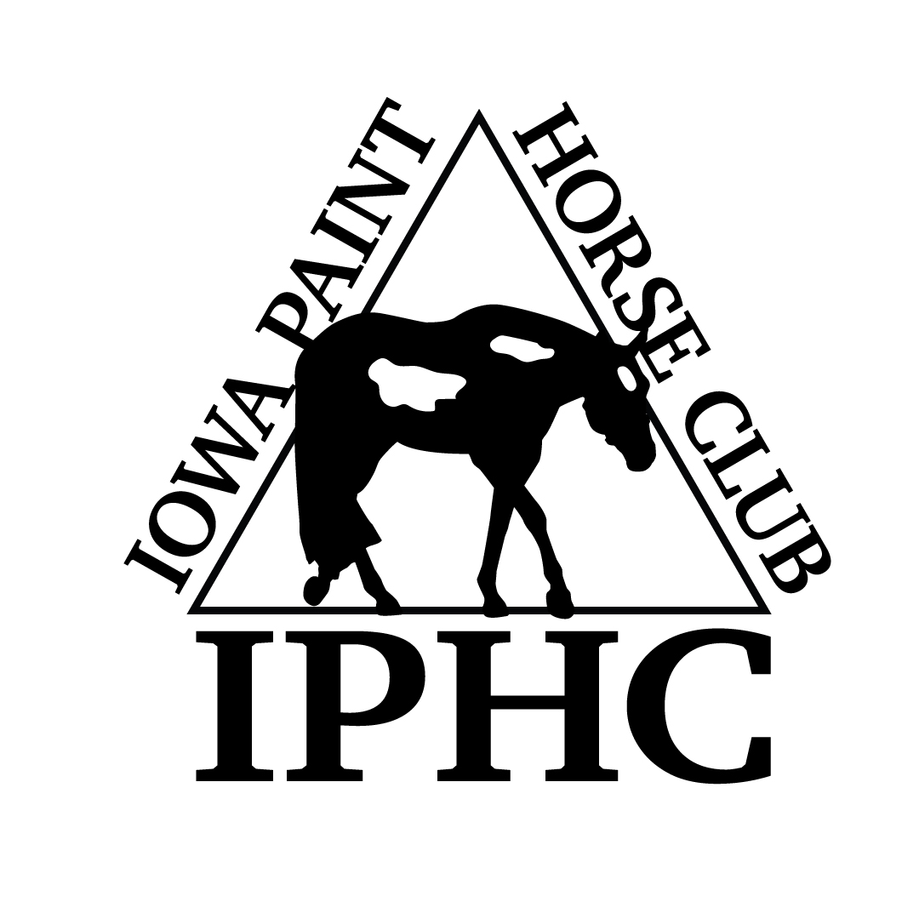
HORSE REGISTRATION PAPERS MUST BE IN HAND FOR VERIFICATION OF OWNERSHIP. CURRENT MEMBERSHIP CARDS, BOTH OWNER & EXHIBITOR MUST BE PRESENTED AT THE SHOW.
IOWA PAINT HORSE CLUB – 2018 ENTRY FORM
Back #
April 26-27, 2014 2014

Name of person who will be paying this horses’s fees:

HORSE INFORMATION (As it appears on the Registration Papers)

- Mare
- Gelding
- Stallion
Registered Name Reg. #: Foal Year

Trainer/Stalled With

OWNER INFORMATION (As it appears on the Registration Papers)

{jpj

Owner APHA # Exp.Date Phone #

Address City,State, Zip

Email

EXHIBITOR INFORMATION (Date of Birth “DOB” required for Youth only)
DP)

EXHIBITOR # 1

EXHIBITOR # 2
Name  APHA # Exp.Date DOB  Address  City,State,Zip  Phone Email  Relationship to Owner  Rider Status: ___ Open ____Amateur ____Novice _____Youth | Name  APHA # Exp.Date DOB  Address  City,State,Zip  Phone Email  Relationship to Owner  Rider Status: ___ Open ____Amateur ____Novice _____Youth
# 1  EXHIBITOR # 3  Name  APHA # Exp.Date DOB  Address  City,State,Zip  Phone Email  Relationship to Owner  Rider Status: ___ Open ____Amateur ____Novice _____Youth | SHOW FEES  ALL FEES REPRESENT A PER DAY/PER HORSE FEE  FEES INCLUDE ALL FEES AND # OF CLASSES INDICATED  - 4 CLASSES OR MORE - $80/PER HORSE, PER DAY  - 2-3 CLASSES - $55/PER HORSE, PER DAY  - 1 CLASS - $30/PER HORSE, PER DAY  Stalls- $65, required to purchase 2 bags of shavings for all horse stalls. Shavings - $8.50/bag. Lead Line Class (Class 90) – Free.  NOTES: 1) If the horse shows in a riding class, halter classes will not count toward your number of classes. 2) Showmanship & Color Classes are NOT halter classes. 3) Longeline: APHA rules. Not approved prior to May 15. 4) Show Management reserves the right to combine classes. 5) All bedding must be purchased from the facility. 6) ALL HORSES MUST HAVE A STALL – NO JUMP OUTS ALLOWED. 7) Per APHA rules, no 2-year old horse may be exhibited in a performance class prior to May 15. Exceptions: Showmanship and 2 Year Old Longe Line.
 |  | SAT |  | SUN |  |  | SAT | SUN |  |  | SAT | SUN
22 | Yth W-T Showmanship 5-10 |  |  |  | 1 | Amateur Pleasure Driving |  |  | 2 | Pleasure Driving
23 | Nov Youth Showmanship 18/U |  |  |  | 3 | Amateur Stallions – All Ages |  |  | 9 | Junior SPB Stallions (2 & Under)
24 | Youth Showmanship 13/U |  |  |  | 6 | Am. SPB Stallions – All Ages |  |  | 10 | Senior SPB Stallions (3 & Over)
25 | Youth Showmanship 18/U |  |  |  | 21 | Amat Walk-Trot Showmanship |  |  | 13 | Performance Halter Stallions
29 | Youth Mares |  |  |  | 26 | Novice Amateur Showmanship |  |  | 14 | Weanling Stallions
49 | Youth Geldings |  |  |  | 27 | Amateur Showmanship |  |  | 15 | Yearling Stallions
74 | Yth W-T Hunter U/Saddle 5-10 |  |  |  | 28 | SPB Amateur Showmanship |  |  | 16 | Two Year Old Stallions
76 | Yth W-T Hunt Seat Eq 5-10 |  |  |  | 30 | Amateur Mares |  |  | 17 | Three Year Old Stallions
77 | Nov Yth Hunter U/Saddle 18/U |  |  |  | 33 | Amateur SPB Mares - All Ages |  |  | 18 | Four Year & Older Stallions
78 | Yth Hunter U/Saddle 13/U |  |  |  | 50 | Amateur Geldings |  |  | 36 | SPB Mares (2 Years & Under)
79 | Yth Hunter U/Saddle 18/U |  |  |  | 53 | Amateur SPB Geldings-All Ages |  |  | 37 | SPB Mares (3 Years & Over)
85 | Nov Yth Hunt Seat Eq 18/U |  |  |  | 69 | Amateur Yearling Longe Line (not at April show) |  |  | 40 | Performance Halter Mares
86 | Yth Hunt Seat Eq 13/Under |  |  |  | 73 | Amat W-T Hunter U/Saddle |  |  | 41 | Weanling Mares
87 | Yth Hunt Seat Eq 18/Under |  |  |  | 75 | Amateur Walk-Trot Equitation |  |  | 42 | Yearling Mares
90 | Lead Line 8 & Under |  |  |  | 81 | Nov Am Hunter Under Saddle |  |  | 43 | Two Year Old Mares
93 | Yth W-T Western Pleasure 5-10 |  |  |  | 82 | Amat Hunter Under Saddle |  |  | 44 | Three Year Old Mares
94 | Yth W-T Horsemanship 5-10 |  |  |  | 83 | SPB Amat Hunter U/Saddle |  |  | 45 | Four Year & Older Mares
98 | Nov Yth West Pleasure 18/U |  |  |  | 88 | Novice Am Hunt Seat Eq |  |  | 46 | Broodmares
99 | Yth Western Pleasure 13/U |  |  |  | 89 | Amateur Hunt Seat Eq |  |  | 56 | SPB Geldings (2 Years & Under)
100 | Yth Western Pleasure 18/U |  |  |  | 92 | Amat W-T Western Pleasure |  |  | 57 | SPB Geldings (3 Years & Over)
105 | Nov Yth Horsemanship 18/U |  |  |  | 95 | Amateur W-T Horsemanship |  |  | 60 | Performance Halter Geldings
106 | Youth Horsemanship 13/U |  |  |  | 102 | Nov Am Western Pleasure |  |  | 61 | Yearling Geldings
107 | Youth Horsemanship 18/U |  |  |  | 103 | Amateur Western Pleasure |  |  | 62 | Two Year Old Geldings
110 | Youth Western Riding 18/U |  |  |  | 104 | SPB Amateur West Pleasure |  |  | 63 | Three Year Old Geldings
117 | Youth Walk-Trot Trail 5-10 |  |  |  | 108 | Nov Amateur Horsemanship |  |  | 64 | Four Year & Older Geldings
118 | Novice Youth Trail 18/U |  |  |  | 109 | Amateur Horsemanship |  |  | 67 | Overo Color
119 | Youth Trail 18/U |  |  |  | 112 | Nov Amateur Western Riding |  |  | 68 | Tobiano Color
124 | Youth Ranch Riding 18/U |  |  |  | 113 | Amateur Western Riding |  |  | 70 | SPB Yearling Longe Line (not at April show)
127 | Youth Ranch Pleasure |  |  |  | 116 | Amateur Walk-Trot Trail |  |  | 71 | Yearling Longe Line (not at April show)
130 | Youth Ranch Reining |  |  |  | 121 | Novice Amateur Trail |  |  | 72 | SPB Hunter Under Saddle
133 | Youth Reining 18/U |  |  |  | 122 | Amateur Trail |  |  | 80 | Green Hunter Under Saddle
 |  |  |  |  | 125 | Amateur Ranch Riding |  |  | 84 | Hunter Under Saddle
Horses are entered at your own risk and are subject to each specific association rules under which these classes will be conducted. In case of death, accident, injury or theft to the exhibitor, their family, horses or property, no claims will be honored either against this show or managing facility. |  |  |  |  | 128 | Amateur Ranch Pleasure |  |  | 91 | Green Western Pleasure
 |  |  |  |  | 131 | Amateur Ranch Reining |  |  | 96 | SPB Western Pleasure
 |  |  |  |  | 134 | Amateur Reining |  |  | 97 | Junior Western Pleasure
 |  |  |  |  |  |  |  |  | 101 | Senior Western Pleasure
 |  |  |  |  | *Horses may enter either regular halter or performance halter, not both. This does not prohibit a horse from being shown in a Youth and/or Amateur halter class in addition to the  open age-group/performance halter class. Horses entered in performance halter MUST enter and participate in a performance class, other than showmanship, that same day. |  |  |  | 111 | Green Western Riding
 |  |  |  |  |  |  |  |  | 114 | Western Riding
 |  |  |  |  |  |  |  |  | 115 | Yearling In-Hand Trail (not at April show)
 |  |  |  |  |  |  |  |  | 120 | Green Trail
# STALLS ____________# TACK STALLS__________  SHAVINGS __________ NUMBER FEE __________  CAMPING ____________NIGHTS |  |  |  |  |  |  |  |  | 123 | Trail
 |  |  |  |  |  |  |  |  | 126 | Ranch Riding
 |  |  |  |  |  |  |  |  | 129 | Ranch Pleasure
 |  |  |  |  |  |  |  |  | 132 | Ranch Reining
 |  |  |  |  |  |  |  |  | 135 | Reining
 |  |  |  |  | Please complete and email to westphal@partnercom.net or mail to Cindy Westphal, 13696 N. 107th Ave E – Gilman, IA 50106
Use the Exhibitor # in the Sat/Sun boxes (instead of an “X”)
Youth/Novice Youth Classes
Amateur/Novice Amateur Classes
Open Classes

